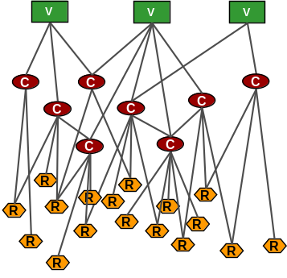  Building a Strategic roadmap based on business capabilities: the Business Innovation Architecture technique | Abstract  Business Innovation Architecture drives business agility in presales by decomposing the customers’ business strategy, business model, business risk into strategic capabilities network and capabilities dashboard.

Contents
Introduction 2
What is Business Innovation Architecture 2
BIA Process Steps and deliverables produced 2
Why BIA 3
Benefits from BIA 3
Business Innovation Architecture Steps 4
Preparation and Definition 4
Understand your Customer 4
Understand Industry 5
Investment (Cost of Sale) 7
Strategic Capabilities Network 7
Capabilities Dashboard 10
Vocabulary 11
Capabilities Architecture 11
Validation 12
Maturity Models 14
Roadmap 14
Execution 15
BIA End to End Execution 15
Conclusion 16
References 17

Introduction

What is Business Innovation Architecture
Business Innovation Architecture hereafter referred as BIA is a technique based on the concepts of consultative sales that brings business agility in pre-sales. BIA is an engagement model as opposed to a workshop model. An engagement model is where the practitioner of BIA works with their customers on a regular basis as opposed to a fly-in do the workshop deliver results and leave workshop model.
BIA is a universal technique and it can be applied in current situation as well as in any strategic shifts and disruptions because the focus of this technique is to drive business innovation for your customer.
“We do our own homework in understanding our customers” This is the quote from the CEO of Southwest airlines in his interaction with the students and dean of business school in Denver Colorado. Doing the homework in understanding their customer has helped Southwest Airlines become the number one airline in terms of customer satisfaction and in achieving profitability for 40 years in a row. Similarly most of the other successful CEOs run their business by doing their homework on their own customer.
Business Innovation Architecture or BIA’s secret sauce is to “Do your own homework for understanding your customer”. As you do your own homework to study your customer, you perform “Customer Thinking”. How to do your own homework is defined in chapter 2.

BIA Process Steps and deliverables produced
BIA has the following three steps:
- Preparation and Definition
In this phase the practitioner gains a better understanding of their customer and produces four deliverables Strategic Capabilities Network (SCN), Capabilities Dashboard, Vocabulary and Capabilities Architecture. The description of these work products can be found in the Business Innovation Architecture Steps section
- Validation
In this phase the practitioner validates the Strategic Capabilities Network, Capabilities Dashboard with the customer and the IBM account team and uses the information to define maturity models for the four domains of the enterprise architecture, business, information (applications and data), and operations. Business Agility and Mobile maturity model for the business domain, Information and Business Intelligence Maturity models for the Information domain, cloud maturity model for the operations domain. In this phase the practitioner refines the SCN, the capabilities dashboard and the capabilities architecture. He uses the maturity models and the capabilities architecture to define a roadmap for execution.
- Execution
The SCN, Capabilities Architecture, Maturity models and the roadmap become the input to the customer’s IT strategy and the validated IBM account plans. Capabilities Dashboard becomes the input to IBM Account Plan and Software Account Plan. The Capabilities Dashboard itself in most instances become the account plan.
The roadmap identifies multiple solution areas. The sales team can then define sales plan, win plan. The architects can produce TeamSD deliverables like the Architecture Overview Diagrams, Component models, operations model and architecture decisions for each of these solution areas. Design thinking from the TeamSD can be applied to refine the solutions.

Why BIA
The first and most important reason for applying BIA is that the customer expects IBM to provide guidance on what the customer should be doing in the next 3 to 5 years and the areas IBM can effectively partner with them. The second most important thing is that for one IBM customer we have 30+ IBM sellers. All these sellers want to reach out to 3 to 4 key decision makers. If you add other vendors there will be 100 plus sellers seeking attention from 3 to 4 key decision makers. BIA provides a validated business strategy aligned capabilities and roadmap for the 30+ IBM sellers to have a more targeted conversation with the customer. The third reason for doing BIA is that IBMers have to be the trusted advisor, guide, coach and mentor to the customer. Too often IBMers get involved once a competitor has shaped the conversation with the customer. BIA changes that and makes the IBMer the trusted advisor and leader in shaping capabilities conversation with the customer before competition.
BIA brings agility in the in the pre-sales process (Identification and validation of opportunities two steps ahead of the competition and one step ahead of IBM customers’ internal IT).

Benefits from BIA

BIA:
- Assists in the creation of the customer business strategy aligned IBM’s account plan
- Provides Business Value for identified opportunities
- Assists in Improved Sales and customer satisfaction
- Provides agile sales engagement
- Transforms the practitioner to becomes Trusted Advisor
- Assists in success with LOB executives

Business Innovation Architecture Steps

Preparation and Definition
In this phase the practitioner gains an understanding of the customer to build “Customer Thinking” and applies the industry knowledge and assets to the gained customer thinking. In this phase the approach is “outside-in” and involves little or no interaction with the customer. All the knowledge is gained from publicly available information about the customer’s business, business strategy and business model.
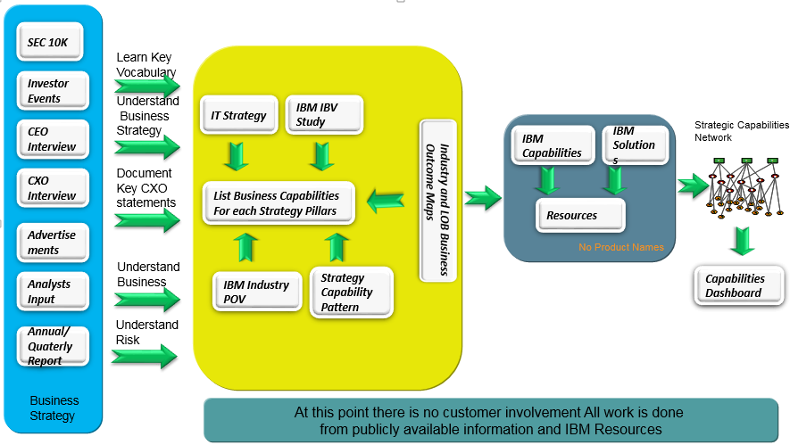
Figure 1 Understand your Customer

Understand your Customer
There is a lot of content that is publicly available that we can use to understand the customer. As shown in figure 2 above, the places to look for customer information are:
- SEC 10k for US based companies and SEC 20F for foreign based companies listed in the United States stock exchange. For the federal and government enterprises, please see the annual financial report or the state of business reports. These are great documents which have accurate information about the customer’s business.
Study the following content in the 10k: Business Strategy, Business Domains, Customers business, Products and services provided by the customer, Business Risk, Competition and Regulation
- Annual Report - Whether it is a foreign enterprise or a US based enterprise they all issue an annual report detailing the forward looking business and the current business performance.
In the annual report, read the 2 to 5 page letter written by the CEO
- Listen to the financial reporting annual and quarterly conference call
- Listen to the Industry Analysts conference calls like J P Morgan, Morgan Stanley etc
- Whether in printed, video or audio format, listen to CEO interviews
- Whether in printed, video or audio format listen to CXO interviews
Review these resources with the goal of understanding and documenting Customer’s business strategy, risk of doing business, customers business, competition, culture, industry and market disruptions. Most of these resources can be found in the Investor Relations section of the customer web site. The 10k can be found in the Edgar website.

Understand Industry
Understanding the industry involves studying
- The IBM institute of business value (IBV) strategy papers and reading the industry 20xx papers.
- The IBM Industry Business Outcome tool
- The industry drivers as defined by the customer’s own documentation and news feeds
- IBM’s industry solutions
- Blueprint solutions
- Read the competitors business; for example in the credit card world; VISA, Master Card, American Express and Discover are competitors. When you study their business you find that American Express is trying to become a payment platform company, they also talk about the changing digital payments platform and services as provided by the likes of Paypal. So you can see two industry drivers here digital payment services agnostic of payment network and payment platform.

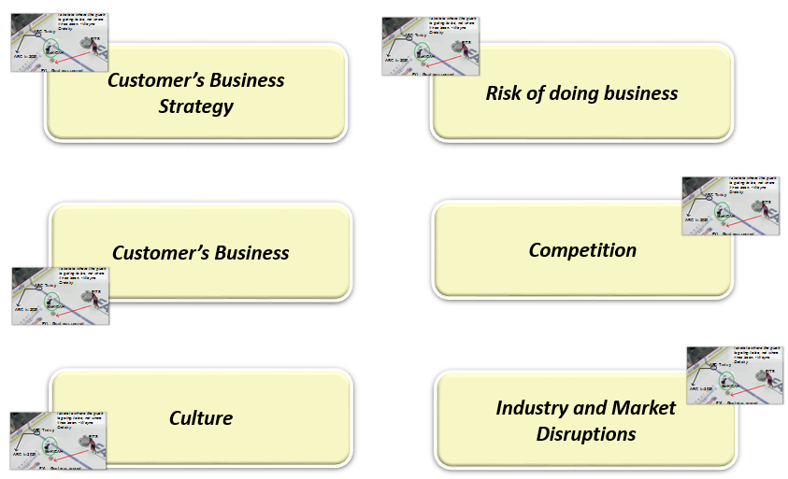
Figure 2 : Documenting the customers’ business understanding
The figure above shows the critical categories of information you want to document from review of the previously listed resources. In general however, the culture of the business enterprise will have to be derived.
For example: The culture of Belk is Modern Southern Style, culture of Southwest is a Low-cost, low fare and customer friendly enterprise, culture of BNSF Railway or National Grid utility is safety first.

Investment (Cost of Sale)
One confusion that a lot of people have is that it takes a lot of time to do the “homework”. One director thought it will take a whole year. However, the fact is that it will probably take around 1 week. Some guidance on the time taken is listed below:
Task | Time
Read 10k (Business, Strategy, Risk, Competition) | 6 hours (Build Vocabulary while you do your homework)
Listen to CEO | 2 hours (Build Vocabulary while you do your homework)
Financial Analysis | 2 hours (Build Vocabulary while you do your homework)
Industry Trends | 6 hours (Build Vocabulary while you do your homework)
IBV Studies | 6 hours (Build Vocabulary while you do your homework)
SCN | 16 hours
Capabilities Dashboard | 4 hours
Figure 3: Time taken to do the Homework
Once the homework is completed BIA advocates the production of three outputs:
- Strategic Capabilities Network
- Capabilities Dashboard and
- Vocabulary

Strategic Capabilities Network
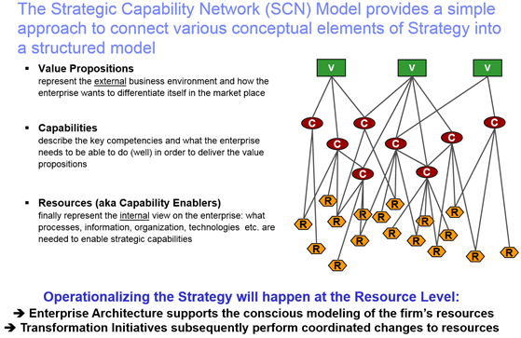
Figure 4: Strategic Capabilities Network
Strategic Capabilities Network (SCN) is a work product from IBM’s Enterprise Architecture (EA) method as presented in the IBM EA class. Most of the enterprise architecture methods including TOGAF, Federal Enterprise Architecture, and DODAF do not have a business strategy component. They focus on business, application, data, and operational architectures and come up with a plan and governance structures and processes.
In the past we have tried to use the Component Business Model (CBM) in presales. However, CBM is viewed by customers and IBM practitioners as a more detailed and thorough method that consumes a lot of time and needs a deeper customer and IBM resource involvement.
SCN on the other hand is a practical approach to the decomposition of the customer’s business value to business capabilities and technology resources.
SCN has three layers: Business Value, Business Capabilities and Resources.
Business Value is the forward looking strategy as defined by the CEO. These can be found in the annual report, 10k, CXO interviews or in the investor presentations. These are the key strategic directions that the enterprise rallies around. Projects are defined, Capabilities are enabled. So in short, this is given to us by the customer. Another way to look at this is “Where the customer needs to be”.
Business Capabilities:
This is a difficult layer to build for the practitioners. Let’s start by understanding What is a business capability. Business Capability according to the definition on the web is “Business capability is the expression or the articulation of the capacity, materials and expertise an organization needs in order to perform core functions.” In IBM’s EA method, business capability is “What an Enterprise needs to do”.
The reason it is difficult is because the list of business capabilities need to be built. The list of business capabilities are not given. Also, the practitioners are not trained in identifying business capabilities. The other problem is that the list of business capabilities is also not available from the customer’s IT organization.
The great thing about business capabilities are that they build a common vocabulary between the Lines of Business and IT. So if you look at the SCN layers, the business capabilities are between business strategy and technology resources linking the strategy with capabilities.
So how can you build a list of business capabilities? The trick here is that when the practitioner is doing the homework as defined above, they should look for business capabilities. They should look for statements that indicate what an enterprise needs to do. Let’s use some example to understand:
Below is one example from a bank:
“The Bank's goal is to mitigate risks in the event of unforeseen threats to the loan portfolio as a result of economic downturn or other negative influences. Plans for mitigating inherent risks in managing loan assets include: carefully enforcing loan policies and procedures, evaluating each borrower's business plan during the underwriting process and throughout the loan term, identifying and monitoring primary and alternative sources for loan repayment, and obtaining collateral to mitigate economic loss in the event of liquidation. Specific loan reserves are established based upon credit and/or collateral risks on an individual loan basis. A risk rating system is employed to proactively estimate loss exposure and provide a measuring system for setting general and specific reserve allocations.”
In the above example the
Enforcement of loan policies and procedures, evaluation of each borrower's business plan during the underwriting process and throughout the loan term, identification and monitoring of primary and alternative sources for loan repayment, and obtaining collateral to mitigate economic loss in the event of liquidation are examples of business capabilities.
Another example from listening to the retailer CEO conference call the following capabilities were documented.
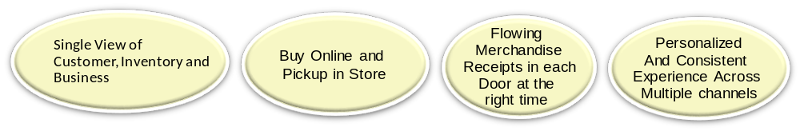

When you do the homework, the business capabilities will not be termed as business capabilities but you have to look for what the customer needs to do.
Technology resources are the services, solutions and technology capabilities that meet the business capabilities. BPM, SOA, Predictive customer insights, analytical decision management are all examples of technology resources. Practitioners are familiar with this as they have been trained in this over a period of time.
While the business value is given to us by the customer, business capabilities is derived from the discussion of the operationalization of the business value by the customer. Technology resources are the resources needed to enable the capabilities. There are 300+ SCNs already available as starter sets for practitioners.
The other good thing about the SCN is that it provides instant business value mappings for the customer. Any leaf node in the graphical representation can be traced back to the business capabilities.
In BIA, SCNs should not include IBM product names or IBM solutions, however, it should include technology areas like Customer insights instead of IBM customer intelligence product. This is done to ensure that the SCNs are not viewed as a sales exercise. One good source of the capabilities can be the IBM Software Product and Capabilities Navigator.
Traditionally an SCN includes decomposition of business strategy. We have innovated and added:
- Decomposition of Business Model
- Decomposition of Business Risk: Business risks are listed in the annual report, 10K statements. Decomposition of business risks gets a lot of traction with customers. Customers are ready to listen to practitioners who can document the capabilities and technology resources to mitigate the business risk.
- Decomposition of the Business: A customer’s business itself provides a lot of guidance in understanding the capabilities needed for enabling the business. For example: Low cost Low fare Airline, Global rental car and car sharing enterprise, infrastructure investment utility.
- Decomposition of industry drivers
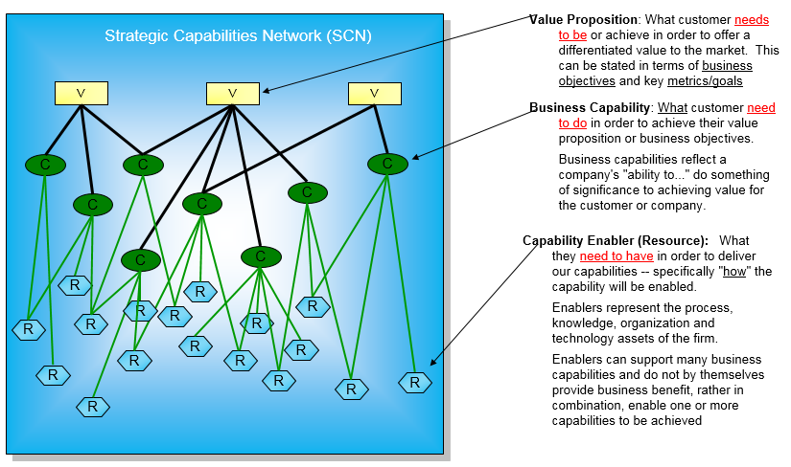
Figure 5: Strategic Capabilities Network Description
Since this is a product agnostic view. This output became the strategy mapping and the planning tool of the customers’ IT executives like the CIO and the CTO in many completed engagements.
This is not a fancy work product, but a very powerful one. If you have a defined SCN you can have a meaningful dialog with the LOB. IT can now use the SCN for a better alignment with the business. SCNs also does not have to be 100% accurate. However if you are 60 to 70% close you have earned the right to have a meaningful dialog with the customer. During validation phase the inaccuracies can be corrected and the SCNs can be refined.
For examples of the completed SCNs please visit this folder in the BIA Community.

Capabilities Dashboard
Capabilities Dashboard is a new output introduced in BIA that does not exist in the Unified Method Framework or TeamSD. This work product is a tabular representation of the SCN but with IBM product, services and solutions mapping. Capabilities Dashboard gives a head-start to the technical sales specialists and the IBM lines of businesses sales teams like Watson Health, Commerce, Security, Cloud, and Analytics for targeted engagement with the customer
For examples of completed Capabilities Dashboard please visit this folder in the BIA Community.

Vocabulary
One of the goals of the BIA is for the practitioner to have a conversation with the LOB’s. This requires strong knowledge of the vocabulary used by the customer. Examples of vocabulary words include: For a retail customer congruency means having the right product at the right place at the right time. For an insurance customer persistency means getting the existing customers policy renewed. The vocabulary should be categorized along the business of the customer. Merchandizing, Financial, Customer, Products etc.
Vocabulary should not be shared with the customer. This is for the practitioners benefit. Key KPI’s used by the customer should also be captured in the vocabulary list. Finally anything that a practitioner does not understand while doing their homework should go in the vocabulary. This artifact is very useful when onboarding new resources to the client team.

Capabilities Architecture
The SCN and Capabilities Dashboard have identified business capabilities. These capabilities need to be enabled in a to-be architecture vision. We leverage the IBM reference architectures from Cloud, Mobile, Social, Security, Business Agility and Information and Business Intelligence as reference. Also the IBM Cloud reference architectures for Mobile, Big Data, Internet of Things, DevOps, Industry and hybrid cloud becomes input to the Capabilities architecture.
The Capabilities architecture is really our “Reference Architecture for the customer”. This architecture talks about technical capabilities without the tight dependency on Current Technical Environment. The notion is this is for conversation purposes as well as a tool to later be able to develop one or more To-Be Architecture Overview Diagrams in the validated business capabilities.
We focus on the capabilities architecture so we do not have to go in details about the customers’ existing architecture.

Validation
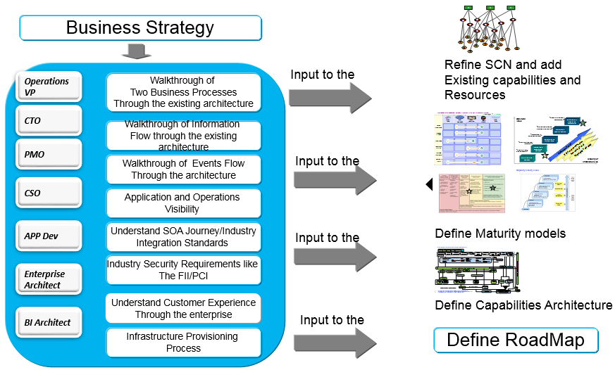
Figure 6: Validating the IBM point of view with the customer
What we need at this point is to validate the point of view with the IBM account team first. This can be done as part of the account planning sessions or if the account planning session has already taken place then it can be also be done directly with the account team. Once the account team has validated and given their inputs, refine the SCN, Capabilities Dashboard and the Capabilities architecture to validate their inputs. Remember the initial POV was from publicly available information and the knowledge of the practitioner about the account.
This is the right time to reach out to the customer CTO or CIO to share your point of view. You discuss the defined SCNs, and Capabilities architecture. Please do not discuss IBM Capabilities Dashboard because we want the conversation to be away from product discussions. Refine the SCN and capabilities dashboard with inputs from the customer CIO and CTO.
At this point get a sponsorship from the CIO and CTO to have the business and IT walkthrough of:
- Two key processes (Select one from operations and other from end-customer engagement) through existing architecture.
Process walkthrough helps us to understand the existing architecture, the gaps in the process enablement, (manual interaction), use of analytics for intelligent decision making and process performance measurement. The process walkthrough answers a lot of questions in assessing the customers’ business agility maturity model. It also showcases how much control the business has over their processes. Use the maturity model questionnaire as catalyst for conversation with the customer. In this walkthrough the practitioner takes good notes and analyzes them later for refining the capabilities architecture and also in defining the maturity models of business agility. The process walkthrough also helps in identifying security holes in the architecture. For example a process walkthrough might suggest that the processes are embedded in the business applications and the control of processes is with the IT organization. It also might suggest that business does not have visibility into the process. Further, it might suggest that business process excellence is only a business initiative and the IT does not support the process excellence.
- Two Information flows through the existing architecture
Information flows give a very good picture of information lifecycle management, existing usages of data marts, warehouses, analytics and business intelligence capabilities of the customer. The practitioner has a defined list of business capabilities. They try to identify the current state and find out what identified business capabilities are supported by the current architecture and the gaps in fulfilling those business capabilities. This is a great way of identifying the maturity of the information and Business intelligence architecture. Use maturity questionnaires as catalysts. Many analytics driven business solutions can be identified using the information walkthrough. Two IT and Business events flow and the actions taken through the architecture
Responsiveness to business events and IT events guides the readiness of the enterprise in collaboration, processes and optimization. IT events and the action taken identifies current IT processes, IT operational failure visibility, and standardization of the implementation of the business capabilities and business processes. It also defines the maturity of the operational architecture and cloud. Business events and the impact of the business events on the operational architecture should be identified.
- Implementation of SOA
A flexible, modular and mature Services Oriented Architecture helps in understanding of the maturity of the customer’s mobile architecture. These services can be transformed to become APIs to be enabled on the mobile devices.
- Security Implementation Walkthroughs
The 4 As of security are Authentication, Authorization, Administration and Auditing. Security should be analyzed at every touch-point in the customers’ ecosystem. A comprehensive security analytics from internal and external events should be used to identify and remove security threats. Cloud and Mobile poses new security challenges in terms of security compliance and a distributed architecture across the multiple cloud implementations. During the walkthrough identify the security readiness of the enterprise and identify security gaps in the current architecture. Use the security maturity questionnaire as catalysts. The security walkthrough assists in the definition of the security maturity architecture. Security is a business problem as it has a huge impact on the business if the customer’s security is compromised.

These walkthrough should not be longer than one hour each. This ensures that we are not taking time away from the employees of the customer’s day job. So if you look at it we have only taken 2 hour from the CIO and CTO and one hour from four customer employees. So BIA uses the minimal involvement from the customer.

Maturity Models
The maturity models are defined for the 4 domains of the Enterprise Architecture (Business, Operations, Application and Information). The maturity models are also created for the IBM CAMSS (Cloud, Analytics, Mobile, Social and Security) strategy. Today the strategy is CAMSS, tomorrow when the strategy changes the CAMSS maturity model definitions might change as well.
While the SCNs, Capabilities Dashboards and the Capabilities architectures are refined after this process, we use the walkthrough to define the maturity models for business agility, information and business intelligence, security, mobile and cloud operational architectures. We do not ask maturity questions directly but infer them from the walkthrough sessions.
IBM’s Assessment and Roadmap (ART) tool can be used to generate the maturity models or use the summary maturity model template to create the maturity models. The ART tool is only used by the IBM practitioner, the customer does not use the ART tool. The advantage of the creation of maturity model is that it helps in documenting the maturity of the customer’s existing architecture and where they want to be. The maturity model provides practical guidance keeping in mind the current state. IBM practitioner can use the gaps to identify technology resources that can help in leap-frogging the current state. It also helps in creating a phased roadmap to improve maturity.
While the IBM’s Assessment and Roadmap (ART) tool is used for technical account planning, in BIA we only use the ART/THA tool for creating the maturity models. Another way of creating the maturity models is the use of maturity model templates.

Roadmap
Based on the maturity models and, capabilities architecture you should define a roadmap of business capabilities enablement. Building of the roadmap should focus on operationalization of the validated SCNs and the Capabilities architecture. The capabilities dashboard can identify technology resources that can enable multiple business capabilities. The idea is to create a roadmap at an enterprise level that can deliver multiple business outcomes. Platform patterns can expedite the operationalization of the roadmap. Also, the roadmap gives guidance on the deeper dive IBM engagements and the timing of the engagement. Further, it provides budget planning guidance to the customer.
This roadmap opens the door to have an IT and LOB conversation for solving business problems, improving the customer KPIs, improving the security, reducing the business risk and delivering the business capabilities for strategy.
Walkthrough the SCN, Capabilities Dashboard, Capabilities Architecture, Maturity Models and roadmap with the IBM account team and then with the customer executives. Refine the SCN, Capabilities Dashboard, Capabilities Architecture, Maturity Models and roadmap with inputs from the customer. We now have a validated capabilities and roadmap for sellers to get engaged.

Execution
This phase has now positioned IBM two steps ahead of competition because IBM now has a validated capabilities dashboard, capabilities architecture, SCN and a roadmap.
IBM Sales needs to now build sales execution plan, win plans, use competitive strategy and engage with customer LOBs and IT executives to showcase to them the value of IBM solutions. Some of the identified and validated capabilities might result in an RFP. However IBM at this point has a better knowledge of the RFP.
Execution also involves governance. The first time’s effort is an asset that needs to be governed. Anytime there is a quarterly report, please study or listen to the analyst conference calls and adjust the BIA deliverables if needed. Also if there is a strategy of competitive changes, please update the BIA deliverables.

BIA End to End Execution
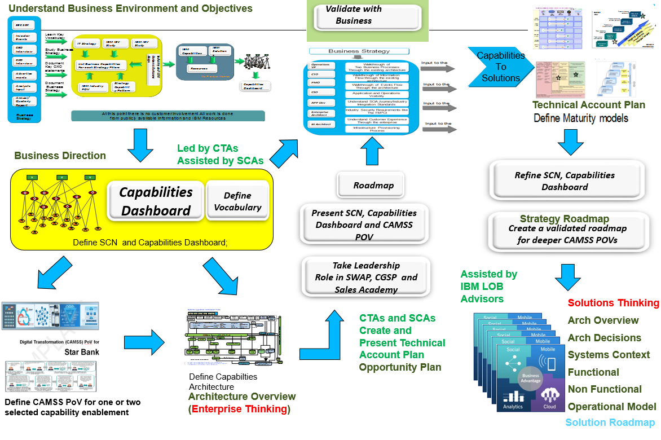
Figure 7: Business Innovation Architecture and IBM Sales Processes and Team SD tasks
We will now define the end-to end steps in executing BIA The steps shown in the Figure 7 are defined below:
- The first step is Understanding Business Environment and Objectives in the upper right corner of Figure 7. This step is performed as a homework step. This step uses publically available materials and does not engage the customer.
- The output of this step is a Strategic Capabilities Network, Capabilities Dashboard and Vocabulary.
- Capabilities Architecture is a to-be architecture that brings together the identified capabilities in the SCN and Capabilities Dashboard portion of the business direction work product. Use the architecture overview and the architecture overview diagram to document the capabilities architecture
- Validate the SCN, Capabilities Dashboard and Capabilities architecture in the IBM Client Growth Strategic Planning (CGSP) and Software Account Planning (SWAP) sessions. This gives the architect a role in these sessions
- If the CGSP and SWAP methods have already be completed validate with the IBM account team outside of the CGSP and the SWAP session
- Validate the SCN, Capabilities Dashboard and Capabilities architecture with customer CIO and CTO and walkthrough of two customers’ business process and information flow and events flow and the security and SOA with the customer IT and business executives
- Create the maturity models for business, information, security, mobile and cloud (operations) using the ART tool or the summary maturity templates
- Refine the SCN, Capabilities Dashboard and Capabilities architecture and then define the roadmap. Use the TeamSD work product Technology plan for documenting the Roadmap using the maturity models, SCN, Capabilities Dashboard and Capabilities architecture
- Validate the BIA outputs with the customer executives
- Use TeamSD tasks and design thinking steps to define solutions of validated business capabilities. Use the Architecture Overview Diagrams, component models, operational models, business drivers and use cases. Use the knowledge gained through homework to evangelize the solutions with the LOBs. Sales now builds the sales execution plan, win plans and relationship maps on the validated business capabilities

Conclusion

BIA transforms IBM to bring agility in the presales engagements by elevating the delivery of IT Value to business value, by incorporating enterprise thinking in the solution thinking and by strengthening the IBM industry point of views to support customer thinking.

References

The Voices of Experience speaker series at the Daniels College of Business with Southwest CEO https://www.youtube.com/watch?v=jo8-LRu63eU
Southwest Airlines Co. is a major U.S. airline and the world’s largest low-cost carrier.
Belk, Inc. is an American mid-range to upscale department store.
Southwest Airlines Co. is a major U.S. airline and the world’s largest low-cost carrier.
The BNSF Railway is one of the largest freight railroad networks in North America.
National Grid plc is a British multinational electricity and gas utility company.
Edgar: Source of 10k filings https://www.sec.gov/edgar/searchedgar/companysearch.html
Institute of Business Value http://www-935.ibm.com/services/us/gbs/thoughtleadership/
Industry Business Outcome Maps http://w3.ibm.com/marketing/mi/mihome.nsf/pages/Industry+Business+Outcomes+Tool?OpenDocument&i=Banking
Bluemine https://w3-03.sso.ibm.com/marketing/mi/mihome.nsf
IBM Blueprint http://w3.blueprint.sby.ibm.com/b_dir/blueprint.nsf vi. How to Read a 10k http://www.sec.gov/answers/reada10k.htm viI Designing with Capabilities http://method.ibm.com/rmchtml_teamsd/core.tech.presales.common.base-ibm_int/guidances/guidelines/resources/designing_with_capabilities.doc viiI Strategic Capabilities Network Patent http://www.google.com/patents/US6249768 ix Know your industry https://learning3.atlanta.ibm.com/sales/learning.nsf/pages/kyi
Enterprise Architecture at Talent@IBM https://w3-151.ibm.com/learning/lms/Saba/Web/Main/goto/learningActivity?courseNum=76908&amp;deepLinkRedirect=false

